Lab # 8

Inheritance

OBJECTive:
To study inheritance and using super to call superclass constructors.

THEORY:

8.1 USING EXISTING CLASSES
Defining a new class based on an existing class is called derivation. The new class, or derived class, is referred to as a direct subclass of the class from which it is derived. The original class is called a base class because it forms the base for the definition of the derived class. The original class is also referred to as a superclass of the derived class. You can also derive a new class from a derived class, which in turn was derived from some other derived class, and so on. This is illustrated in Figure.

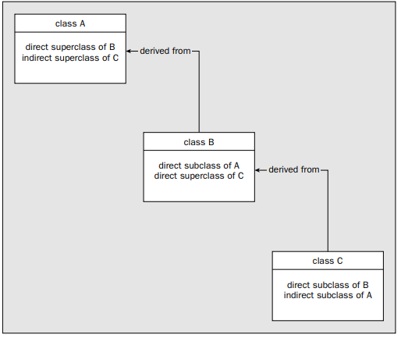

8.2 CLASS INHERITANCE

In summary, when you derive a new class from a base class, the process is additive in terms of what makes up a class definition. The additional members that you define in the new class establish what makes a derived class object different from a base class object. Any members that you define in the new class are in addition to those that are already members of the base class.
The inclusion of members of a base class in a derived class so that they are accessible in that derived class is called class inheritance. An inherited member of a base class is one that is accessible within the derived class. If a base class member is not accessible in a derived class, then it is not an inherited member of the derived class, but base class members that are not inherited still form part of a derived class object.

Inheriting Data Members:

Figure shows which access attributes permit a class member to be inherited in a subclass. It shows what happens when the subclass is defined in either the same package or a different package from that containing the base class. Remember that inheritance implies accessibility of the member in a derived class, not just presence.

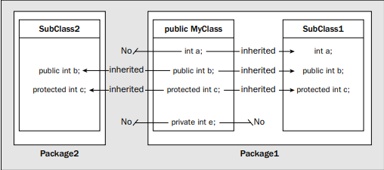

Inheritance Basics:

To inherit a class, you simply incorporate the definition of one class into another by using the extends keyword. To see how, let’s begin with a short example. The following program creates a superclass called A and a subclass called B. Notice how the keyword extends is used to create a subclass of A.

// A simple example of inheritance.
// Create a superclass.
class A
{
int i, j;
void showij()
{
System.out.println("i and j: " + i + " " + j);
}
}

// Create a subclass by extending class A.
class B extends A
{
int k;
void showk()
{
System.out.println("k: " + k);
}
void sum()
{
System.out.println("i+j+k: " + (i+j+k));
}
}

class SimpleInheritance
{
public static void main(String args[])
{
A superOb = new A();
B subOb = new B();
// The superclass may be used by itself.
superOb.i = 10;
superOb.j = 20;
System.out.println("Contents of superOb: ");
superOb.showij();
System.out.println();
/* The subclass has access to all public members of
its superclass. */
subOb.i = 7;
subOb.j = 8;
subOb.k = 9;
System.out.println("Contents of subOb: ");
subOb.showij();
subOb.showk();
System.out.println();
System.out.println("Sum of i, j and k in subOb:");
subOb.sum();
}
}

Output:

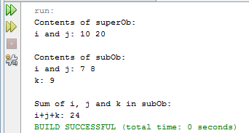

8.3 CALLING THE BASE CLASS CONSTRUCTOR

Using super:

super has two general forms. The first calls the superclass’ constructor. The second is used to access a member of the superclass that has been hidden by a member of a subclass.

Using super to Call Superclass Constructors

A subclass can call a constructor method defined by its superclass by use of the following form of super:

super(parameter-list);

Here, parameter-list specifies any parameters needed by the constructor in the superclass. super( ) must always be the first statement executed inside a subclass’ constructor.

class Box {
private double width;
private double height;
private double depth;
// construct clone of an object
Box(Box ob) { // pass object to constructor
width = ob.width;
height = ob.height;
depth = ob.depth;
}

// constructor used when all dimensions specified
Box(double w, double h, double d) {
width = w;
height = h;
depth = d;
}

// compute and return volume
double volume() {
return width * height * depth;
}
}

// BoxWeight now fully implements all constructors.
class BoxWeight extends Box {
double weight; // weight of box
// construct clone of an object
BoxWeight(BoxWeight ob) { // pass object to constructor
super(ob);
weight = ob.weight;
}
// constructor when all parameters are specified
BoxWeight(double w, double h, double d, double m) {
super(w, h, d); // call superclass constructor
weight = m;
}
}

class DemoSuper {
public static void main(String args[]) {
BoxWeight mybox1 = new BoxWeight(10, 20, 15, 34.3);
BoxWeight myclone = new BoxWeight(mybox1);
double vol;

vol = mybox1.volume();
System.out.println("Volume of mybox1 is " + vol);
System.out.println("Weight of mybox1 is " + mybox1.weight);
System.out.println();

vol = myclone.volume();
System.out.println("Volume of myclone is " + vol);
System.out.println("Weight of myclone is " + myclone.weight);
System.out.println();
}
}

Output:

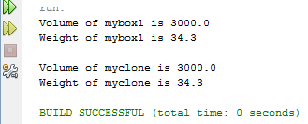

LAB TASK

- Develop a registration system for a University. It should consist of three classes namely Student, Teacher, and Course. For example, a student needs to have a name, roll number, address and GPA to be eligible for registration. Therefore choose appropriate data types for encapsulating these properties in a Student objects. Similarly a teacher needs to have name, address, telephone number, and a degree (or a list of degrees) he/she has received. Finally courses must have a name, students (5 students) registered for the course, and a teacher assigned to conduct the course. Create an object of Course with 5 Students and a Teacher. A call to a method, say printDetails(), of the selected course reference should print name of the course, details of the teacher assigned to that course, and names and roll numbers of the students enrolled with the course.
class Student{
static String name;
static int roll_no;
static int semester;
static double GPA;
Student(String name,int roll,int sem, double gpa){
this.name = name;
this.roll_no = roll;
this.semester = sem;
this.GPA = gpa;

}
void show_info(){
System.out.println("\tThe name of student is "+Student.name);
System.out.println("\tThe roll is "+Student.roll_no);
System.out.println("\tThe semester is "+this.semester);
System.out.println("\tThe GBA is "+this.GPA);
}
}
class Teacher{
static String name;
static String address;
static String[] qualifications;
static String phone_num;
Teacher(String name, String address, String[] qualifications,
String phone_num){
this.name = name;
this.address = address;
this.qualifications = qualifications;
this.phone_num = phone_num;
}
Teacher(Teacher t){
this.name = t.name;
this.address = t.address;
this.qualifications = t.qualifications;
this.phone_num = t.phone_num;

}
void show_info(){
System.out.println("Name : "+this.name);
System.out.println("Address : "+this.address);
System.out.println("Phone number : "+this.phone_num);
System.out.println("Qualifications");
for(int i = 0 ; i < this.qualifications.length; i++){
System.out.println("\t"+qualifications[i]);
}
}
}
class Course extends Teacher{
Student[] students;
String course_name;
int course_points;
Course(Teacher teacher ,Student[] students, String course_name, int course_points){
super(teacher);
this.students = students;
this.course_name = course_name;
this.course_points = course_points;

}
void printDetails(){
System.out.println("Course "+this.course_name);
System.out.println("Teacher :");
this.show_info();
System.out.println("Students: ");
for (Student student : this.students) {
student.show_info();
}
}
}
public class uni_reg{
public static void main(String[] args){
Student[] class_fellows = {
new Student("Mustaba Unus",74,2,3.0),
new Student("Haider yousuf",50,2,3.2),
new Student("yameen mughal",40,2,2.8),
new Student("Zahid Azhar",12,2,3.5),
new Student("sahid Azher",22,2,3.6)
};
Teacher course_teacher;
String[] q = {"bachelours in Comp sci","masters in comp sci"};
course_teacher = new Teacher("Sir Khaliq","G house Grove street Ganton",q,"290886");
Course algo_course = new Course(course_teacher,class_fellows,"Introduction to algorithums",100);
algo_course.printDetails();
}
}

Output

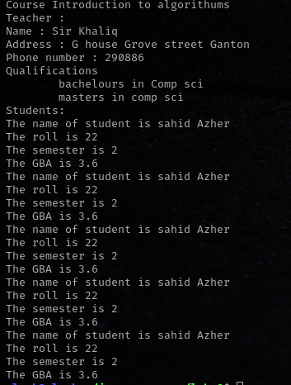

2. Create a class called computers and two classes MyComputer and YourComputer which inherits computer class. Define appropriate features of their processor in the classes. Create another class processor as a composite class of computer. Write a method which prints the differences between the processors of two computers.
Example:
single core:
bandwidth = 125GByte/s
speed = slow
processing = sequentially

class Computer{
String model,CPU,GPU,OS;
double clock;
int memory;
int storage;
Computer(String model, String CPU,double clock,int memory,int storage,String GPU,String OS){
this.model = model;
this.clock = clock;
this.CPU = CPU;
this.memory = memory;
this.storage = storage;
this.GPU = GPU;
this.OS = OS;
}
Computer(String model,String CPU,double clock,int memory,int storage){
this.model = model;
this.clock = clock;

this.CPU = CPU;
this.memory = memory;
this.storage = storage;
this.OS = "\0";
this.GPU = "\0";
}
Computer(Computer c1){
this.model = c1.model;
this.clock = c1.clock;

this.CPU = c1.CPU;
this.memory = c1.memory;
this.storage = c1.storage;
this.OS = "\0";
this.GPU = "\0";
}

void compareProcessors(Computer c1,Computer c2){
if(c1.clock > c2.clock){
System.out.println(c1.model+" processor is better then "+c2.model);
} else if(c1.clock == c2.clock){
System.out.println("Both systems are requal in speed");
} else {
System.out.println(c2.clock+" processor is better then "+c1.clock);
}
}

}
class myComputer extends Computer{
String user;
myComputer(String name, String model,String CPU,double clock,int memory,
int storage){
super(model, CPU, clock, memory, storage);
this.user = user;
}
myComputer(String name,Computer c1){
super(c1);
this.user = user;
}
}
class yourComputer extends Computer{
String user;
yourComputer(String name, String model,String CPU,double clock,int memory,
int storage){
super(model, CPU, clock, memory, storage);
this.user = user;
}
yourComputer(String name, Computer c1){
super(c1);
this.user = user;
}
}
public class my_computer{
public static void main(String[] args){
myComputer my_comp = new myComputer("Zohaib","think pad T420","intel i5",3.3,4096,250);
yourComputer your_comp = new yourComputer("Zobia","Optiplex 755","Core 2 quad",3.2,6124,500);
my_comp.compareProcessors(my_comp, your_comp);

}
}

output

